Order No.: 01-20108-020
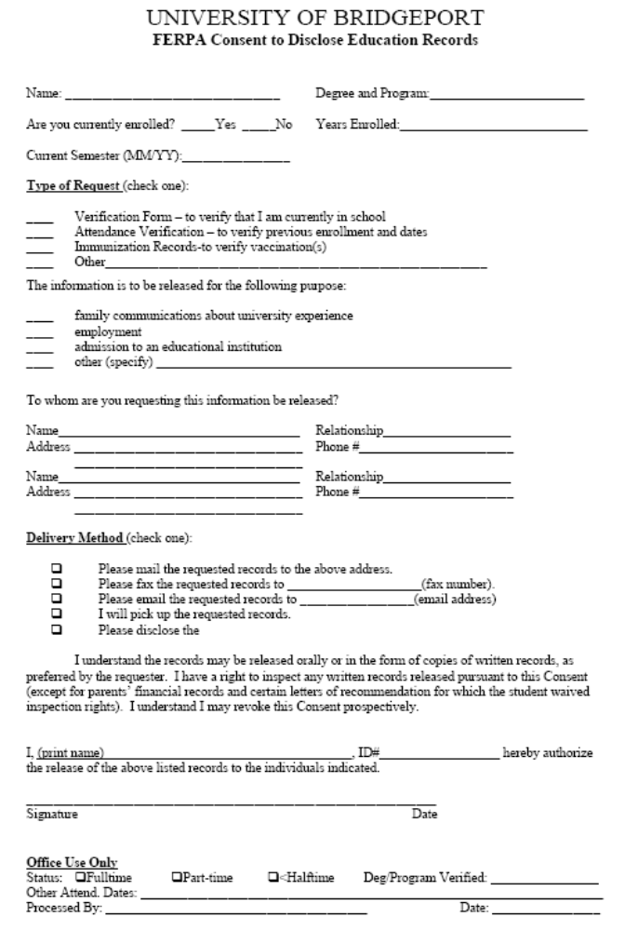
X Any and All Records
2869 Jolly Rd (877) 886-5090
Laura Knoblauch
Axiom Requisition Copy Service
Okemos, MI 48864
Laura Knoblauch
X Legal matter
X

